**Candidate Name**:- Amrutha H

**Superset ID**:-6421402

**WEEK – 1 HANDS ON EXERCISE (JAVA FSE DEEPSKILLING)**

**(PL/SQL Programming)**

**Exercise 1: Control Structures**

**Scenario 1:** The bank wants to apply a discount to loan interest rates for customers above 60 years old.

* **Question:** Write a PL/SQL block that loops through all customers, checks their age, and if they are above 60, apply a 1% discount to their current loan interest rates.

BEGIN

EXECUTE IMMEDIATE 'DROP TABLE Customers';

EXCEPTION

WHEN OTHERS THEN NULL;

END;

/

-- Customer table

CREATE TABLE Customers (

CustomerID NUMBER,

Name VARCHAR2(50),

Age NUMBER,

LoanInterestRate NUMBER(5,2),

Balance NUMBER(10,2),

IsVIP VARCHAR2(5),

LoanDueDate DATE

);

-- Insert data into table

INSERT INTO Customers VALUES (1, 'Alice', 65, 8.5, 12000, NULL, SYSDATE + 10);

INSERT INTO Customers VALUES (2, 'Bob', 45, 7.2, 9500, NULL, SYSDATE + 40);

INSERT INTO Customers VALUES (3, 'Carol', 70, 9.1, 20000, NULL, SYSDATE + 5);

INSERT INTO Customers VALUES (4, 'Dave', 30, 6.5, 10500, NULL, SYSDATE + 25);

--Scenario 1:

BEGIN

FOR cust IN (SELECT CustomerID FROM Customers WHERE Age > 60) LOOP

UPDATE Customers

SET LoanInterestRate = LoanInterestRate - 1

WHERE CustomerID = cust.CustomerID;

END LOOP;

COMMIT;

END;

SELECT CustomerID, Name, Age, LoanInterestRate FROM Customers;

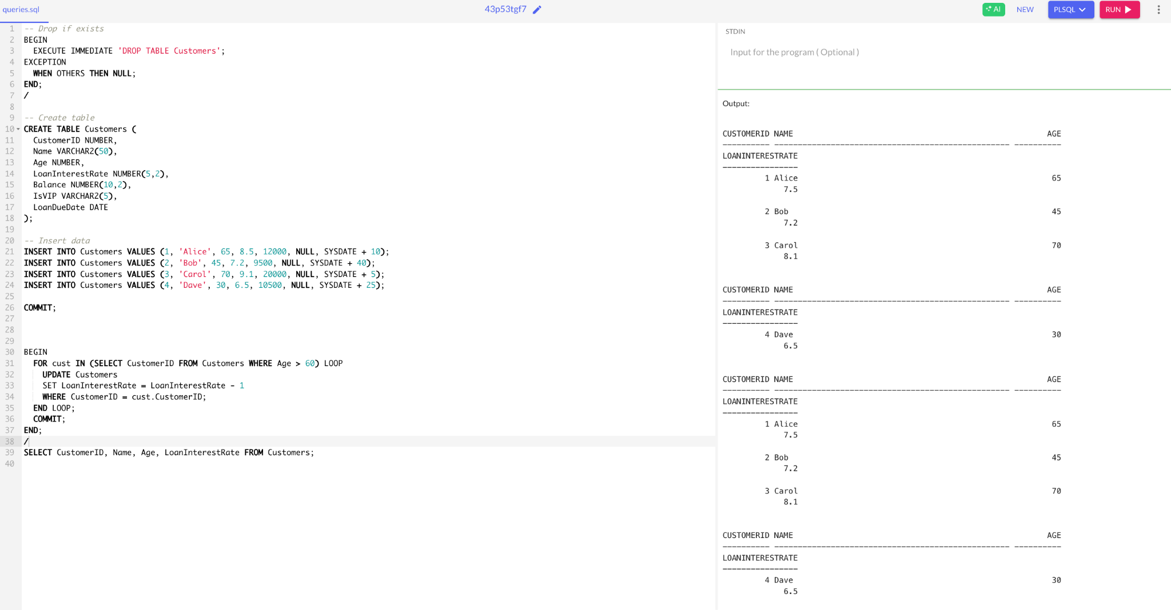

**Scenario 2:** A customer can be promoted to VIP status based on their balance.

* **Question:** Write a PL/SQL block that iterates through all customers and sets a flag IsVIP to TRUE for those with a balance over $10,000.

**The table creation and inserting value is same as mentioned above in scenario1 after that this code should be executed.**

BEGIN

FOR cust IN (SELECT CustomerID, Balance FROM Customers) LOOP

IF cust.Balance > 10000 THEN

UPDATE Customers SET IsVIP = 'TRUE' WHERE CustomerID = cust.CustomerID;

ELSE

UPDATE Customers SET IsVIP = 'FALSE' WHERE CustomerID = cust.CustomerID;

END IF;

END LOOP;

COMMIT;

END;

/

SELECT CustomerID, Name, Balance, IsVIP FROM Customers;

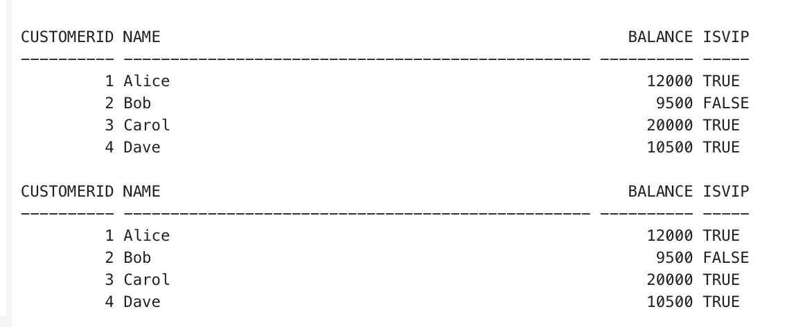

BEGIN

DBMS_OUTPUT.ENABLE;

END;

/

-- Print reminders

BEGIN

FOR cust IN (

SELECT Name, LoanDueDate, CustomerID

FROM Customers

WHERE LoanDueDate <= SYSDATE + 30

) LOOP

DBMS_OUTPUT.PUT_LINE('Reminder: ' || cust.Name ||

' (CustomerID: ' || cust.CustomerID || ') has a loan due on ' ||

TO_CHAR(cust.LoanDueDate, 'DD-Mon-YYYY'));

END LOOP;

END;

/

